Hoosier Highlights

DLC
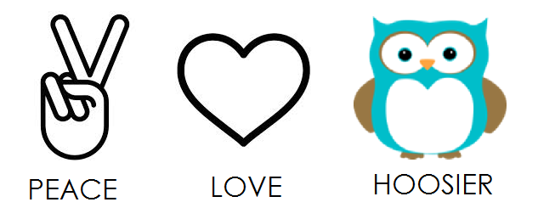
DLC is an awesome Key Club weekend filled with fun snd learning. During this weekend, Key Clubbers go to workshops, groups lessons, and even a Key Club dance. This is a really good way to bring back a lot of skills and ideas to your club. This year, DLC is March 31st- April 2nd. I encourage you all to have some of your club members go!

Key Leader Recap
Key Leader was a fun filled weekend at Camp Tecumseh. The club members there learned new leadership skills and the characteristics of a good leader. These are definitely good things to use in your clubs and generally in the world. I hope you can all go next year!

Do The Dues
Don’t forget to pay your dues! They are completely due on December 1st. If you don’t know how much you need to pay for your dues, ask your advisor or club President.

Pacer’s Game
The Indiana District Key Club is selling tickets to the Pacers vs. Portland Trail Blazers game on Saturday, December 10th. These tickets are only $25 and are being sold to support the Three Wishes Campaign. This campaign will promote early autism diagnosis across Indiana. It will also help provide more places over Indiana for children to be diagnosed. Our last wish is to bring awareness to all of Indiana. If you are interested, please email me!

